Timeline of the Voyage of Charles Darwin and the HMS Beagle Name _________________________________

Directions: Use the Web Site http://www.aboutdarwin.com/voyage/voyage01.html to gather specific information regarding the voyage of the HMS Beagle. In each box below list two stops the HMS Beagle made during that specific time period of their journey. On the following pages write a summary of each stop you listed on the timeline. * There was only one stop from April to October of 1835. On the following pages write a brief summary of the stops you listed on the timeline.

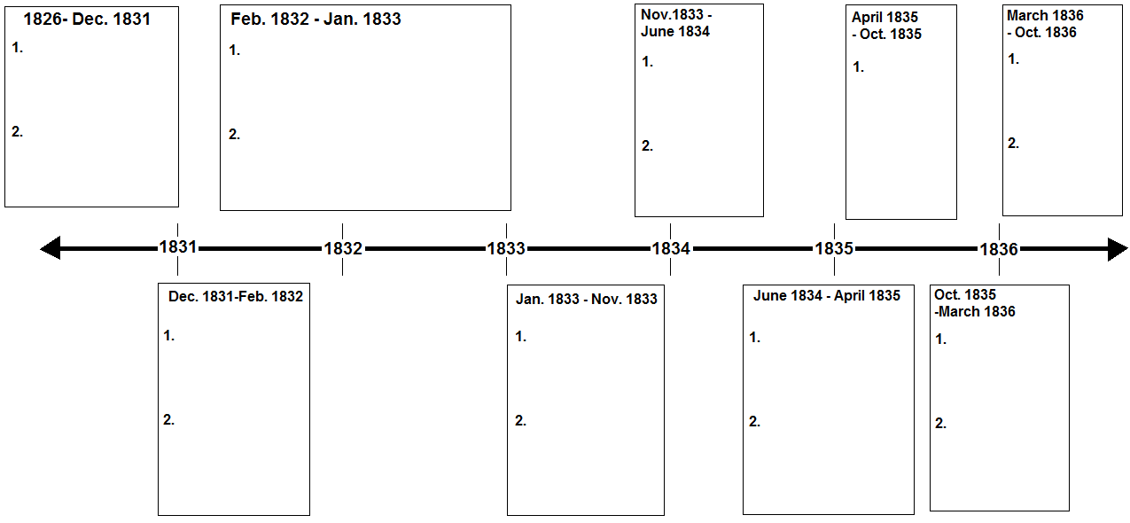

1826 – December 1831

1. __________________________________________________________________________________________________________

____________________________________________________________________________________________________________

____________________________________________________________________________________________________________

____________________________________________________________________________________________________________

2. __________________________________________________________________________________________________________

____________________________________________________________________________________________________________

____________________________________________________________________________________________________________

____________________________________________________________________________________________________________

December 1831 – February 1832

1. __________________________________________________________________________________________________________

____________________________________________________________________________________________________________

____________________________________________________________________________________________________________

____________________________________________________________________________________________________________

2. __________________________________________________________________________________________________________

____________________________________________________________________________________________________________

____________________________________________________________________________________________________________

____________________________________________________________________________________________________________
February 1832 – January 1833

1. __________________________________________________________________________________________________________

____________________________________________________________________________________________________________

____________________________________________________________________________________________________________

____________________________________________________________________________________________________________

2. __________________________________________________________________________________________________________

____________________________________________________________________________________________________________

____________________________________________________________________________________________________________

____________________________________________________________________________________________________________

January 1833 – November 1833

1. __________________________________________________________________________________________________________

____________________________________________________________________________________________________________

____________________________________________________________________________________________________________

____________________________________________________________________________________________________________

2. __________________________________________________________________________________________________________

____________________________________________________________________________________________________________

____________________________________________________________________________________________________________

____________________________________________________________________________________________________________
November 1833 – June 1834

1. __________________________________________________________________________________________________________

____________________________________________________________________________________________________________

____________________________________________________________________________________________________________

____________________________________________________________________________________________________________

2. __________________________________________________________________________________________________________

____________________________________________________________________________________________________________

____________________________________________________________________________________________________________

____________________________________________________________________________________________________________

June 1834 - April 1835

1. __________________________________________________________________________________________________________

____________________________________________________________________________________________________________

____________________________________________________________________________________________________________

____________________________________________________________________________________________________________

2. __________________________________________________________________________________________________________

____________________________________________________________________________________________________________

____________________________________________________________________________________________________________

____________________________________________________________________________________________________________
April 1835 – October 1835

1. __________________________________________________________________________________________________________

____________________________________________________________________________________________________________

____________________________________________________________________________________________________________

____________________________________________________________________________________________________________

____________________________________________________________________________________________________________

____________________________________________________________________________________________________________

____________________________________________________________________________________________________________

____________________________________________________________________________________________________________

October 1835 – March 1836

1. __________________________________________________________________________________________________________

____________________________________________________________________________________________________________

____________________________________________________________________________________________________________

____________________________________________________________________________________________________________

2. __________________________________________________________________________________________________________

____________________________________________________________________________________________________________

____________________________________________________________________________________________________________

____________________________________________________________________________________________________________
March 1836 – October 1836

1. __________________________________________________________________________________________________________

____________________________________________________________________________________________________________

____________________________________________________________________________________________________________

____________________________________________________________________________________________________________

____________________________________________________________________________________________________________

____________________________________________________________________________________________________________

____________________________________________________________________________________________________________

2. __________________________________________________________________________________________________________

____________________________________________________________________________________________________________

____________________________________________________________________________________________________________

____________________________________________________________________________________________________________

____________________________________________________________________________________________________________

____________________________________________________________________________________________________________

____________________________________________________________________________________________________________

